Equilibrium Notes

# Reaction Rate

* For a reaction to occur, particles must:
  + Collide
  + Collide in correct orientation
  + Possess sufficient energy ($E_{a}$)
* To affect reaction rate, collisions and/or energy can be manipulated
* Reaction rates are affected by:
  + Nature of reactants (RR of reactants vary with components)
    - Collisions require lower $E_{a}$ for reaction to occur
    - Surface area and/or concentrations (essentially same)
      * Both cause higher frequency of collisions per unit time
    - Temperature
      * Increases frequency of collisions
      * Increase in $E_{k}$
    - Pressure
      * Increase in concentration and $E_{k}$ (increases number of moles per unit area. Also, as:
 $$PV=nRT$$     * temperature is proportional to pressure when volume, and number of moles of gas is constant
    - Catalysts
      * allows for the reaction to take an alternate pathway with a lower activation energy.
      * Therefore, a larger proportion of particles have sufficient activation energy to react

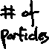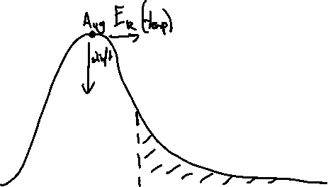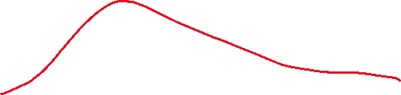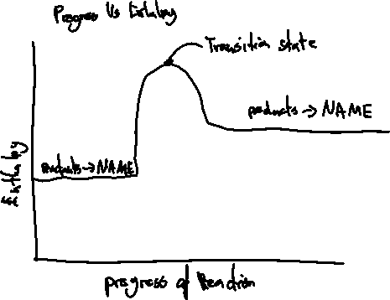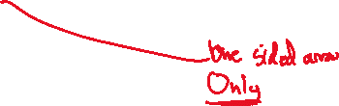

# Equilibrium

* A system is in dynamic equilibrium if the rate of forward reaction is equal to the rate of reverse reaction. The concentration of reactants and products remains constant
* A system in equilibrium has constant macroscopic properties
* Criteria for equilibrium:
  + Reversable reaction
  + In a closed system (Open systems allow for reactants or products to escape to atmosphere)
* Phase change of substances are in equilibrium if they are in a closed system

*Ex. 1*

$${Heat+H}_{2}O_{(l)} {}_{←}^{→}{{ H}_{2}O_{(g)}}$$

* *When water is heated in a closed container, water will transition into gas. Therefore, pressure within container will increase. As pressure increases, water will begin to condensate, hence reverse reaction rate increases. Therefore, when forward reaction rate and reverse reaction rate are equal, the system is in equilibrium.*

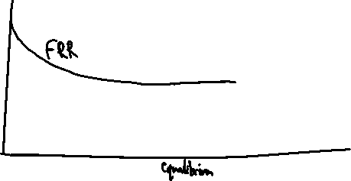

* As reaction progresses, [reactants] decrease and [products] increase. Therefore, FRR decreases (lower frequency of collisions between reactant-reactant particles per unit time) and RRR increases (higher frequency of collisions between product-product particles per unit time). When FRR = RRR, system is in equilibrium.
* A solution is saturated if no more solutes can be dissolved under given conditions.
* Amount of solute dissolved is equal to the amount of ions converted back to solid because FRR=RRR in a saturated solution.

# Equilibrium Constant

* Equilibrium constant (K) measures concentration of products relative to concentration of reactants:
  + - [x] is raised to the coefficient
    - x cannot be a solid or liquid (as solids or liquids don’t have concentrations)
    - If no reactant or product, use 1 in equation
    - No plus or minus -> only charge of ion
* K is specific and defined at a certain temperature
* When K>1 ⇒ [products]>[reactants]
* When K<1 ⇒ [products]<[reactants]
* K is conserved unless temperature is changed (only temperature can change K)
* Value of K provides no information of rate of reaction

# Equilibrium Shift

* To make a shift, **concentration** or **temperature** must change
* Volume change will affect all gases and change in FRR and RRR
* Catalyst will not alter concentration or temperature ⇒ will not cause shift
* Addition or subtraction of noble gas **under constant volume** does not alter concentration or temperature ⇒ will not cause shift
* Addition or subtraction of noble gas **under constant pressure** changes volume or temperature or system. Change in volume or temp ⇒ shift
* Belly shape in concentration graph implies temperature change (no sudden change)
$$Concentration∝\frac{1}{Volume}$$

* Follow product in concentration graph to determine direction of shift and type of shift
* Pressure change ⇒ side of equation with highest number of moles of gas is affected most
  + If no gas, or moles of gas are equal on both sides ⇒ no shift
* Water change ⇒ side of equation with highest number of aqueous moles is affected most
  + If no aqueous, or moles of aqueous are equal on both sides ⇒ no shift
* If solid is added, look at solubility

## Indirect effect

* Ions combine with other ions present in the solution to precipitate a solid. Therefore, [solution ions] decreases and equilibrium will shift
* Hydroxide can remove hydrogen ions to form water (neutralisation reaction)

## Observation

* When describing colour changes, state initial colour change, then after some time
* Model observation answer:

Le Chatlier’s Principle (to be used for reason for observation only – not explanation)

* LCP states that when a change is introduced to a system in equilibrium, the system will rearrange its reaction to partially oppose the change.

## Reaction Rate Graph

* FRR will decrease with time. As this occurs, RRR will increase (as more product is produced)
* FRR = RRR at equilibrium
* Similar to normal graph of FR and RR
* When Catalyst is added, FRR and RRR will increase by same amount
* When increasing concentration or adding heat, final rate is bigger than before
* When decreasing concentration or removing heat, final rate is lower than before
* Always draw heat in equation for temperature

# Model Answers

1. Observation/prediction of colour change:
   1. When x is added, [x] increases, which is *colour*. Therefore, initially, solution turns more *colour*. Then chemical equilibrium will shift to the *direction* (FR/RR favoured) to partially oppose the change in [x] (increase in [x]). Therefore, [y] will increase, which is *colour2*. Therefore, solution will turn more *colour2* and less *colour*.
2. Equilibrium shift (change in [x])
   1. When x is added, [x] increases. Therefore, there are a higher number of collisions of x per unit time (increase in frequency of collisions). Therefore, the FRR will increase initially. After some time, the number of reactant particles will decrease as products are produced. Therefore, RRR increases as more products are produced and FRR decreases slightly. At equilibrium FRR=RRR and [products] and [reactants] remains unchanged.

Marking key answers:

At t1, temperature of the system was increased. Explain your answer using collision theory.

2 NOBr(g) ⇋ 2 NO(g) + Br2(g) ∆H < 0

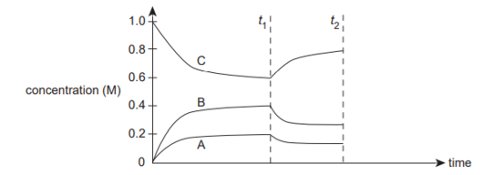

* **The temperature was increased (1)**
* **Products are being used up/reaction moving in the endothermic/reverse direction (1)**
* **Increase in temperature increases both rates as more particles on both sides have sufficient energy to overcome Ea (1)**
* **Endothermic rate (reverse) is increased proportionally more as it has the higher Ea barrier (1)**

**Stage 2: N2(g) + 3 H2(g) ⇋ 2 NH3(g) ∆H = - 92 kJ**

For this second stage, the two gases are introduced into the reaction vessel in a 1:3 stoichiometric ratio, the reaction is carried out at temperatures ranging between 350 – 550 ⁰C, pressures of 10-25 MPa and in the presence of a porous iron oxide (Fe2O3) catalyst.

Use collision theory to explain why these conditions are chosen to optimise the yield and reaction rate in **Stage 2** of the Haber process.

In your response, address any compromises in conditions and make reference to economic and safety considerations. (11 marks)

|  |  |
| --- | --- |
| **Temperature** |  |
| **A high temperature is required to maximise the rate of reaction because a greater proportion of particles will:**   * **Be moving faster and so collide more frequently and** * **Have sufficient energy to overcome Ea, resulting in a greater proportion of successful collisions** | **1-2** |
| **A low temperature is required to maximize yield because:**   * **The forward rate is exothermic, a high temperature will favour the reverse/endothermic rate** * **as this has the higher activation energy barrier/the reverse rate would therefore overtake the forward rate** | **1-2** |
| * **A moderature temperature is therefore chosen as a compromise between increasing yield, while maintaining rate** | **1** |
| **Pressure** |  |
| * **A high pressure is required to maximize the rate as a high pressure will result in a higher frequency of collisions** * **As particles are more concentrated, making collisions more likely** | **1-2** |
| * **A high pressure also increases the yield as the forward rate is increased proprotionally more than the reverse** * **Due to molar ratios of 4:2/being dependent on the collision of a larger number of particles** | **1-2** |
| **Economic and safety considerations** |  |
| **Any two (detailed answer not required)**   * **Use of catalyst allows to maintain high rate at lower temperature** * **Use of high pressure may introduce safety risk** * **Reactant ratio 1:3 used to optimise yield** | **2** |

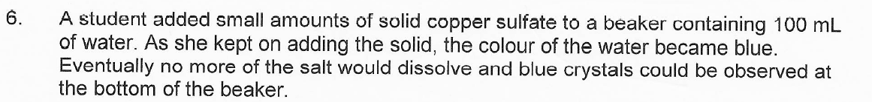

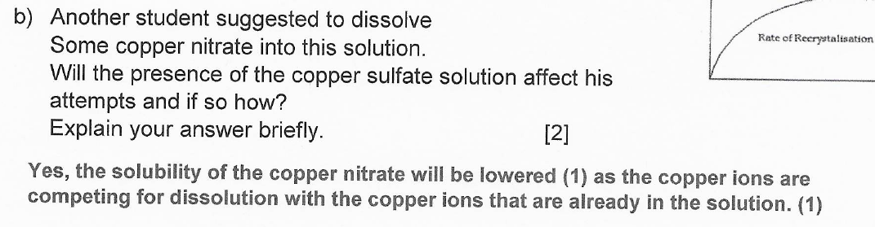

# Mistakes

* *‘Goes to completion’ ⇒ [products] >> [reactants]
* ALWAYS PUT AN ANSWER IN MULTPLE CHOICE
* *if [products] or [reactants] decrease ⇒ FRR and RRR decreases overall at equilibrium
* ALWAYS MAKE REFERENCE TO [product] or [reactant] when referring to rate of other
* ****PRECIPITATE/GAS FORMED IN OBSERVATION IF APPLICABLE
* Solid does not change concentration, only reaction rate (solid does not have a concentration)
* Observations: Describe initial effect first, then after some time
* ****[products] or [reactants] will never return to original concentration
  + ****Overall concentration decreases if water added/pressure decreased/volume increased
* If K=[only one substance], [substance] can only be changed by temperature, as K can only be changed by temperature
* **Account for safety and economic reasons for evaluating pressure in industrial process:
  + Safety ⇒ High pressure vessels are unsafe
  + Economic ⇒ High pressure vessels are costly to build
* *Define K value if explaining what it means when given experimental values
* *Add Ea forward and Ea reverse in Energy Profile Diagrams
* Ensure moles counted are correct in dilution/pressure/volume questions
* Not all reactants are necessarily plotted on graph
* READ THE QUESTION – don’t assume if two substances are on same line initially, they are both reactants/products
* Don’t assume labels correspond to what you think they should be
* Make reference to equilibrium/reaction rate in explanations always when possible
* Less (colour)/paler instead of turns colourless